Student Attendance System Specification
Version 1.1

I. Student Attendance Management System
1. Student and Lecturer Information Management
- The system stores and manages student information, including:
+ Student ID (unique), full name, date of birth, gender, address, phone number, email, and class.
- The system stores and manages lecturer information, including:
+ Lecturer ID (unique), full name, date of birth, gender, phone number, email, and department.
- Each student and lecturer has a separate account to log in to the system.
- Each account includes a username, password, and user role.
- The administrator is responsible for creating, updating, and managing student and lecturer accounts. Students and lecturers are not allowed to register accounts themselves.
- The system ensures that each student ID, lecturer ID, and username is unique.
2. Login and Account Management
- Users must log in before using protected system functions.
- The system authenticates login credentials and grants access according to the user's role: Student, Lecturer, or Administrator.
- Users can view their own personal information and change their passwords.
- Users are not allowed to access functions beyond their authorized permissions.
3. Course and Course Enrollment Management
- Each course has the following information: course ID (unique), course name, number of credits, semester, and academic year.
- The administrator has the authority to create, update, and manage course information.
- The administrator manages student course enrollments, including viewing enrollment lists, adding students to courses, and updating enrollment information.
4. Class Session Management and Lecturer Assignment
- Each class session belongs to a course organized in the corresponding semester and academic year.
- Class session information includes session ID, course, class date, start time, end time, location, and session status.
- The administrator has the authority to create, update, and manage class sessions.
- The administrator assigns lecturers to be responsible for courses.
- Lecturers can only view and take attendance for courses and class sessions assigned to them.
- A class session can be locked when the attendance period ends. After being locked, the system does not allow new attendance records to be recorded or completed attendance records to be changed automatically.
5. Student Attendance
- Lecturers select the course and class session for which attendance needs to be taken.
- The system displays the list of students enrolled in the corresponding course.
- Lecturers record attendance for each student by selecting one of the following three statuses:
+ Present.
+ Absent.
+ Late.
- The system supports attendance recording through manual status selection.
- The system automatically records the attendance timestamp when processing attendance information.
- Each student has only one attendance record for each class session, unless the system has specific rules for recording multiple entries.
- When the attendance period ends, the system automatically locks the class session and does not allow new attendance records to be recorded.
6. Viewing Attendance Information and Statistics
- Students can view their own attendance history, including courses, class sessions, timestamps, and attendance statuses.
- Students can view their own attendance rates for each enrolled course.
- The system calculates attendance rates based on attendance data from the corresponding course sessions.
- Lecturers can view attendance results for class sessions belonging to their assigned courses.
- Lecturers can view attendance statistics by course, class session, and student.
- The system supports summarizing the number of Present, Absent, and Late sessions.
7. Attendance Change History Management
- The system records the history of attendance status changes, including record information, the status before the change, the status after the change, the person who made the change, and the time of the change.
- Lecturers have the authority to view change history for attendance data within their assigned scope.
-- Administrators have the authority to view attendance change history across the entire system.
8. System Administration
The administrator has the following functions:
- Manage student accounts.
- Manage lecturer accounts.
- Manage course information.
- Manage course enrollments.
- Manage class sessions.
- Manage lecturer assignments.
- View system-wide attendance reports.
- View attendance change history.

II. Supplementary Specification
1. Usability
- The system interface must be easy to use, clear, and consistent.
- The interface must automatically adapt to screen sizes (responsive), supporting computers and mobile phones.
- Functions must be displayed according to the user's role: Student, Lecturer, or Administrator.
- The attendance interface must clearly display the three statuses: Present, Absent, and Late to reduce input errors.
2. Reliability
- The system must operate continuously 24/7, except during announced maintenance periods.
- System availability must be at least 99.9%.
- The system must ensure the accuracy and consistency of student, lecturer, course, class session, and attendance record data.
- The system must not change locked attendance records automatically.
3. Performance
- The system must support multiple concurrent users, including students, lecturers, and administrators.
- The system must be scalable as the number of users, courses, class sessions, and attendance records increases.
- Attendance history retrieval, statistics, and reporting functions must return results within a reasonable time under the expected operational load.
4. Supportability
- The system must be designed with a clear structure to facilitate maintenance and upgrades.
- The system must allow function updates, bug fixes, and system expansion without unnecessarily affecting existing data.
- The system must support logging errors and important activities for inspection and troubleshooting.
- Data must be backed up periodically to support recovery when necessary.
5. Security
- Users must log in before accessing protected functions.
- The system must apply role-based access control for Student, Lecturer, and Administrator.
- Students can only view their own personal information, attendance history, and attendance rates.
- Lecturers can only manage and view attendance data belonging to the courses and class sessions assigned to them.
- Administrators can access management functions according to their granted permissions.
- The system must prevent students from modifying their own attendance records or those of other students.
- Attendance record updates must be subject to access control and have their change history recorded.
6. Development Requirements
- The system must be developed using an appropriate architecture and technology to facilitate maintenance and expansion.
- The database must ensure data integrity and consistency.
- The development process must comply with secure programming principles and access control requirements.
- The system must be tested for its main functions, including login, data management, attendance recording, statistics, and access control.
- Design documentation, user documentation, and installation guides must be prepared to support system deployment and maintenance.

III.Functional Requirements
Core Features & Capabilities
-Attendance Recording: The system must allow the recording of students' attendance status (Present, Absent, Late).
-Input Processing: The system must accept attendance inputs via the specified method
-Automated Timestamping: The system must automatically lock and save the exact date and time when an attendance entry is successfully processed.
-Situational Behavior: The system must automatically switch a student's status from "Present" to "Late" if they check in 15 minutes after the class start time.
-Session Locking: The system must automatically close and disable the attendance session when the time window set by the instructor expires.
What the system should NOT do
-No Unauthorized Modification: The system must not allow students to edit their own attendance logs or those of other students under any circumstances.
-No Retroactive Alterations: The system must not automatically change historical attendance records once a past session has been locked and finalized.

IV. Non-Functional Requirements
Timing & Performance Cosntraints
-Response Time: The system must process and confirm a single attendance check-in within 2 seconds to prevent queues at the classroom entrance.
-Data Synchronization: Attendance data must sync with the central database within 5 seconds of a successful scan or entry.
Security & Availability Cosntraints
-Access Control: Only authenticated instructors or system administrators are permitted to override or manually modify attendance data.
-System Availability: The system must achieve 99.9% uptime during scheduled class hours to guarantee that attendance can be taken without disruption.

V.Data Flow Diagram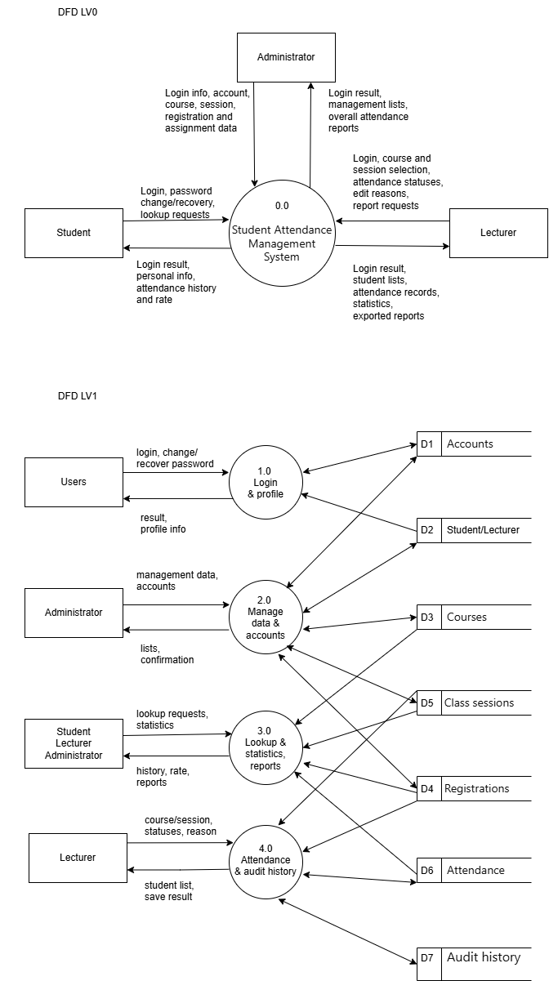
VI. Use case diagram
1.Overview diagram
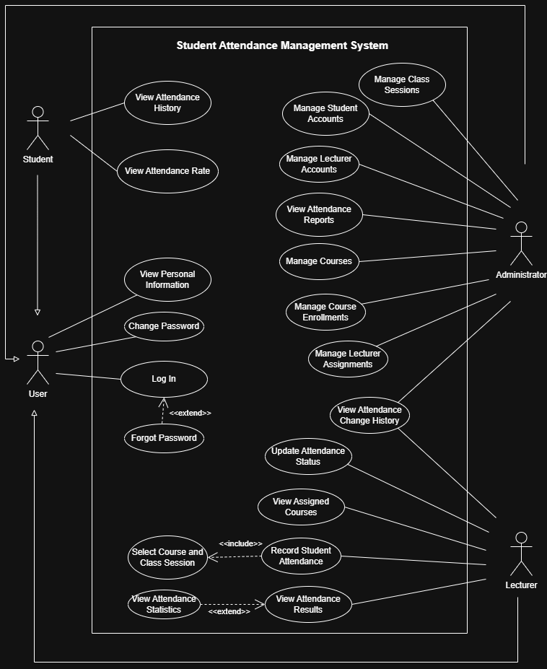
  - List of Actor

Numerical order | Actor | Meaning
1 | User | A general system user who can log in, view personal information, and change their password
2 | Student | Student can view personal information, attendance history, and attendance rates for enrolled courses.
3 | Lecturer | Lecturer can view assigned courses, record attendance, update attendance statuses, and view attendance statistics..
4 | Administrator | Administrator can manage accounts, courses, class sessions, course enrollments, and lecturer assignments, and view overall attendance reports.

  - List of Use Cases
Numerical order | Use-case | Meaning
1 | Log In | Log in to the system.
2 | Forgot Password | Recover the password when a user forgets it.
3 | View Personal Information | View the user's personal information.
4 | Change Password | Change the account password.
5 | View Attendance History | View the student's attendance history.
6 | View Attendance Rate | View the attendance rate for each course.
7 | Manage Student Accounts | Manage student accounts, including creating, updating, and managing accounts.
8 | Manage Lecturer Accounts | Manage lecturer accounts.
9 | Manage Courses | Manage course information.
10 | Manage Class Sessions | Manage class sessions belonging to courses.
11 | Manage Course Enrollments | Manage the list of students enrolled in courses.
12 | Manage Lecturer Assignments | Manage the assignment of lecturers responsible for courses.
13 | View Attendance Reports | View overall attendance reports for the entire school.
14 | View Assigned Courses | View the list of courses assigned to the lecturer.
15 | Select Course and Class Session | Select the course and class session for which attendance needs to be taken.
16 | Record Student Attendance | Record the attendance status of each student.
17 | Update Attendance Status | Update attendance statuses and save the edit history.
18 | View Attendance Results | View students' attendance results in assigned courses.
19 | View Attendance Statistics | View students' attendance statistics and attendance trends.
20 | View Attendance Change History | View the history of attendance status changes according to the assigned permissions.

2. Use-case Login
2.1 Summary
This Use Case describes how users log in to the Student Attendance Management System using a username and password. Allows users to log in and access functions based on their roles.
2.2 Flow of Events
2.2.1 Main Flow
The Use Case begins when the user wants to log in to the system.
- The system displays the login form.
- The user enters a username and password, then selects the login function.
- The system checks the provided login information.
- If the information is valid, the system identifies the user's role.
- The system allows the user to access the functions corresponding to their role.
- The system notifies the user that the login is successful.
2.2.2. Alternative Flows
Case 1: Incorrect username or password
1.If the login information is incorrect, the system displays an error message.
2.The user can re-enter the login information or terminate the login process.
Case 2: Account without access permission
1.If the account is disabled or is not permitted to access the system, the system denies the login.
2.The system notifies the user of the result.
2.3. Special Requirements
- The password must be securely protected during storage and authentication.
- The system must enforce a role-based access control mechanism.
- Users must not access functions beyond their permissions.
2.4 System State Before Executing the Use Case
The user has not logged in to the system and already has a valid account.
2.5 System State After Executing the Use Case
- If the login is successful, the user is authenticated and can access the functions for which permission is granted.
- If the login fails, the user remains in the not-logged-in state.
2.6 Extension Points
Use Case Forgot Password: The user can switch to the password recovery function when forgetting the password.
3. Use-case Forgot Password
3.1 Summary
This Use Case allows users to recover their passwords when they forget their passwords.
3.2 Flow of Events
3.2.1 Main Flow
The Use Case begins when the user wants to log in to the system.
1. The system displays the password recovery interface and asks the user to enter their registered username or email.
2. The user enters the required information and submits a password recovery request.
3. The system checks the account information.
4. If the account is valid, the system performs the password recovery process.
5. The system notifies the user of the password recovery result.
3.2.2. Alternative Flows
Case 1: Account does not exist
- The system displays an error and allows the user to retry.
Case 2: Account does not have access permission
- The system displays an error and asks the user to try again later.
3.3. Special Requirements
None.
3.4 System State Before Executing the Use Case
The user has an account in the system but does not remember the password and has not logged in.
3.5 System State After Executing the Use Case
- If the password recovery is successful, the user can use the new password to log in.
- If the password recovery fails, the account information remains unchanged.
3.6 Extension Points
None.
4. Use-case View Personal Information
4.1 Summary
This Use Case allows users to view their personal information in the Student Attendance Management System.
4.2 Flow of Events
4.2.1 Main Flow
The Use Case begins when the user selects the View Personal Information function.
1.The system identifies the account of the logged-in user.
2.The system retrieves the personal information corresponding to the account.
3.The system displays the user's personal information.
4.2.2 Alternative Flows
- If the information cannot be found, the system displays an error message.
4.3 Special Requirements
- Users are only allowed to view their own personal information.
- The system must protect personal information through a role-based access control mechanism.
4.4 System State Before Executing the Use Case
The user has successfully logged in to the system.
4.5 System State After Executing the Use Case
None.
4.6 Extension Points
None.
5. Use-case Change Password
5.1 Summary
The Change Password Use Case allows users to change their account passwords after logging in to the system.
5.2 Flow of Events
5.2.1 Main Flow
1.The user selects the Change Password function.
2.The system displays the password change form.
3.The user enters the current password, the new password, and confirms the new password.
4.The system checks the validity of the current password.
5.The system checks whether the new password and the confirmation password match.
6.If the information is valid, the system updates the new password.
7.The system notifies the user that the password change is successful.
8.The Use Case ends.
5.2.2 Alternative Flows
- Incorrect current password or mismatched confirmation: The system displays an error and requests correction.
5.3 Special Requirements
- The password must be protected according to the system's security requirements.
- Users are only allowed to change the passwords of their own accounts.
5.4 System State Before Executing the Use Case
None.
5.5 System State After Executing the Use Case
- If successful: The account password is updated to the new password.
- If unsuccessful: The account password remains unchanged.
5.6 Extension Points
None.
6. Use-case View Attendance History
6.1 Summary
The View Attendance History Use Case allows students to view their own attendance history, including the attendance status of each class session.
6.2 Flow of Events
6.2.1 Main Flow
1. The student selects the View Attendance History function.
2. The system identifies the student's account.
3. The system retrieves the student's attendance history.
4. The system displays the attendance history, including class session information and attendance statuses such as Present, Absent, or Excused.
5. The Use Case ends.
6.2.2. Alternative Flows
None.
6.3. Special Requirements
- Students are only allowed to view their own attendance history.
- Lecturers are only allowed to view attendance history for assigned courses.
6.4 System State Before Executing the Use Case
None.
6.5 System State After Executing the Use Case
None.
6.6 Extension Points
None.
7. Use-case View Attendance Rate
7.1 Summary
The View Attendance Rate Use Case allows students to view their attendance rate for class sessions in the system.
7.2 Flow of Events
7.2.1 Main Flow
1.The student selects the View Attendance Rate function.
2.The system identifies the logged-in student's account.
3.The system retrieves the student's attendance data.
4.The system calculates the attendance rate based on the attendance data.
5.The system displays the student's attendance rate.
6.The Use Case ends.
7.2.2 Alternative Flows
- Insufficient data: The system explains that the rate cannot be calculated.
7.3 Special Requirements
- Students are only allowed to view their own attendance rates.
- The attendance rate must be calculated based on the attendance data in the system.
- The system must ensure the accuracy of the displayed data.
7.4 System State Before Executing the Use Case
None.
7.5 System State After Executing the Use Case
None.
7.6 Extension Points
None.
8. Use-case Manage Student Accounts
8.1 Summary
The Manage Student Accounts Use Case allows the Administrator to manage student accounts in the system, including creating accounts, viewing information, updating information, and managing student account statuses.
8.2 Flow of Events
8.2.1 Main Flow
1.The Administrator logs in to the system.
2.The Administrator selects the Manage Student Accounts function.
3.The system displays the list of student accounts.
4.The Administrator selects an account management function, including creating a new account, viewing information, or updating student information.
5.The system displays the form or information corresponding to the selected function.
6.The Administrator enters information or performs the necessary operation.
7.The system checks the validity of the data.
8.If the data is valid, the system saves the changes to the database.
9.The system notifies the result of the operation.
10.The Use Case ends.
8.2.2 Alternative Flows
None.
8.3 Special Requirements
- Only the Administrator is allowed to manage student accounts.
- Each student account must be uniquely identified in the system.
- The system must validate the information before saving it.
- The system must protect student account information and apply an access control mechanism.
8.4 System State Before Executing the Use Case
- The Administrator is logged in and has permission to manage student accounts.
8.5 System State After Executing the Use Case
- Success: The account is created or updated, or its information is displayed..
- If unsuccessful: The system displays an error message and does not save invalid changes.
8.6 Extension Points
None.
9. Use-case Manage Lecturer Accounts
9.1 Summary
The Manage Lecturer Accounts Use Case allows the Administrator to manage lecturer accounts in the system, including creating new accounts, viewing information, and updating lecturer account information.
9.2 Flow of Events
9.2.1 Main Flow
1.The Administrator logs in to the system.
2.The Administrator selects the Manage Lecturer Accounts function.
3.The system displays the list of lecturer accounts.
4.The Administrator selects an account management function, including creating a new account, viewing information, or updating lecturer information.
5.The system displays the corresponding form or information.
6.The Administrator enters information or performs the necessary operation.
7.The system checks the validity of the data.
8.If the data is valid, the system saves the changes to the database.
9.The system notifies the result of the operation.
10.The Use Case ends.
9.2.2 Alternative Flows
None.
9.3 Special Requirements
- Only the Administrator may manage lecturer accounts.
- Account identifiers must be unique; data must be validated before saving.
9.4 System State Before Executing the Use Case
- The Administrator is logged in and authorized..
9.5 System State After Executing the Use Case
- Success: Account information is created, updated, or displayed.
- Failure: Existing data remains unchanged.
9.6 Extension Points
None.
10. Use-case Manage Courses
10.1 Summary
The Manage Courses Use Case allows the Administrator to manage courses in the system, including creating new courses, viewing information, and updating course information.
10.2 Flow of Events
10.2.1 Main Flow
1.The Administrator logs in to the system.
2.The Administrator selects the Manage Courses function.
3.The system displays the list of courses.
4.The Administrator selects a course management function, including creating a new course, viewing information, or updating course information.
5.The system displays the form or information corresponding to the selected function.
6.The Administrator enters information or performs the necessary operation.
7.The system checks the validity of the data.
8.If the data is valid, the system saves the changes to the database.
9.The system notifies the result of the operation.
10.The Use Case ends.
10.2.2 Alternative Flows
None.
10.3 Special Requirements
- Only the Administrator may manage courses.
- Course data must be validated and course identifiers must be unique.
10.4 System State Before Executing the Use Case
- The Administrator is logged in and authorized.
10.5 System State After Executing the Use Case
- Success: Course information is created, updated, or displayed.
- Failure: Invalid changes are not saved.
10.6 Extension Points
None.
11. Use-case Manage Class Sessions
11.1 Summary
The Manage Class Sessions Use Case allows the Administrator to manage class sessions belonging to courses in the system, including creating new class sessions, viewing information, and updating class session information.
11.2 Flow of Events
11.2.1 Main Flow
1.The Administrator logs in to the system.
2.The Administrator selects the Manage Class Sessions function.
3.The system displays the list of class sessions.
4.The Administrator selects the course whose class sessions need to be managed.
5.The system displays the list of class sessions belonging to the selected course.
6.The Administrator selects the function to create a new class session, view information, or update a class session.
7.The system displays the corresponding form or information.
8.The Administrator enters class session information or performs the necessary operation.
9.The system checks the validity of the data.
10.If the data is valid, the system saves the class session information to the database.
11.The system notifies the result of the operation.
12.The Use Case ends.
11.2.2 Alternative Flows
None.
11.3 Special Requirements
- Only the Administrator may manage class sessions.
- Each session must belong to a valid course, and session details must be validated.
11.4 System State Before Executing the Use Case
- The Administrator is logged in and authorized.
11.5 System State After Executing the Use Case
- Success: Session information is created, updated, or displayed.
- Failure: Invalid changes are not saved.
11.6 Extension Points
None.
12. Use-case Manage Course Enrollments
12.1 Summary
The Manage Course Enrollments Use Case allows the Administrator to manage student course enrollments, including viewing the enrollment list, adding students to courses, and updating enrollment information.
12.2 Flow of Events
12.2.1 Main Flow
1.The Administrator logs in to the system.
2.The Administrator selects the Manage Course Enrollments function.
3.The system displays the course enrollment list.
4.The Administrator selects the course whose enrollments need to be managed.
5.The system displays the list of students enrolled in that course.
6.The Administrator selects the function to add a student to the course or update enrollment information.
7.The system displays the corresponding form.
8.The Administrator enters the student and course information or updates the enrollment information.
9.The system checks the validity of the information.
10.The system checks whether the student has already enrolled in that course.
11.If the information is valid and there is no duplicate enrollment, the system saves the enrollment information to the database.
12.The system notifies the result of the operation.
13.The Use Case ends.
12.2.2 Alternative Flows
None.
12.3 Special Requirements
- Only the Administrator may manage enrollments.
- A student must not be enrolled in the same course more than onc.
12.4 System State Before Executing the Use Case
- The Administrator is logged in and authorized; the relevant student and course exist.
12.5 System State After Executing the Use Case
- Success: Enrollment data is updated..
- Failure: Invalid changes are not saved..
12.6 Extension Points
None.
13. Use-case Manage Lecturer Assignments
13.1 Summary
The Manage Lecturer Assignments Use Case allows the Administrator to manage the assignment of lecturers to courses in the system, including viewing the assignment list, creating new assignments, and updating assignment information.
13.2 Flow of Events
13.2.1 Main Flow
1.The Administrator logs in to the system.
2.The Administrator selects the Manage Lecturer Assignments function.
3.The system displays the lecturer assignment list.
4.The Administrator selects the function to create a new assignment or update assignment information.
5.The system displays the lecturer assignment form.
6.The Administrator selects the lecturer and the course to be assigned.
7.The system validates the lecturer and course information.
8.The system checks whether the assignment already exists.
9.If the information is valid and there are no duplicates, the system saves the assignment information to the database.
10.The system notifies the Administrator of the result.
11.The Use Case ends.
13.2.2 Alternative Flows
None.
13.3 Special Requirements
- Only the Administrator may manage assignments.
- Assignments must reference valid lecturers and courses.
13.4 System State Before Executing the Use Case
- The Administrator is logged in and authorized.
13.5 System State After Executing the Use Case
- Success: The assignment is saved.
- Failure: Existing assignments remain unchanged.
13.6 Extension Points
None.
14. Use-case View Attendance Reports
14.1 Summary
The View Attendance Reports Use Case allows the Administrator to view overall attendance reports for the entire system and the Lecturer to view attendance reports for the courses assigned to them.
14.2 Flow of Events
14.2.1 Main Flow
1.The user successfully logs in to the system.
2.The user selects the View Attendance Reports function.
3.The system identifies the user's role and access permissions.
4.The system displays the attendance report viewing options appropriate to the user's permissions.
5.The user selects the course or report scope to view.
6.The system retrieves the corresponding attendance data.
7.The system aggregates the data and generates the attendance report.
8.The system displays the report to the user.
9.The Use Case ends.
14.2.2 Alternative Flows
None.
14.3 Special Requirements
- Reports must follow user permissions and accurately reflect stored attendance data.
14.4 System State Before Executing the Use Case
None.
14.5 System State After Executing the Use Case
- Success: The report is displayed..
- Failure: The system displays an appropriate message.
14.6 Extension Points
None.
15. Use-case View Assigned Courses
15.1 Summary
The View Assigned Courses Use Case allows the Lecturer to view the list of courses assigned to them by the Administrator. The Lecturer can view information about each course to support teaching activities and attendance management.
15.2 Flow of Events
15.2.1 Main Flow
1.The Lecturer successfully logs in to the system.
2.The Lecturer selects the View Assigned Courses function.
3.The system identifies the lecturer account currently logged in.
4.The system retrieves the list of courses assigned to the Lecturer.
5.The system displays the course list along with related information.
6.The Lecturer selects a course to view its details.
7.The system displays the details of the selected course.
8.The Use Case ends.
15.2.2 Alternative Flows
None.
15.3 Special Requirements
- Lecturers may view only courses assigned to them.
15.4 System State Before Executing the Use Case
- The Lecturer is logged in..
15.5 System State After Executing the Use Case
None.
15.6 Extension Points
None.
16. Use-case Select Course and Class Session
16.1 Summary
The Select Course and Class Session Use Case allows the Lecturer to select an assigned course and the corresponding class session to perform student attendance operations.
16.2 Flow of Events
16.2.1 Main Flow
1.The Lecturer successfully logs in to the system.
2.The Lecturer selects the student attendance function.
3.The system displays the list of courses assigned to the Lecturer.
4.The Lecturer selects a course.
5.The system displays the list of class sessions belonging to the selected course.
6.The Lecturer selects a class session for which attendance needs to be recorded.
7.The system checks the access permissions and the information of the selected class session.
8.The system displays the list of students enrolled in the course corresponding to the selected class session.
9.The Use Case ends.
16.2.2 Alternative Flows
None.
16.3 Special Requirements
- The Lecturer may select only assigned courses and their valid class sessions.
16.4 System State Before Executing the Use Case
- The Lecturer is logged in and has an assigned course.
16.5 System State After Executing the Use Case
None.
16.6 Extension Points
None.

17. Use-case Record Student Attendance
17.1 Summary
The Record Student Attendance Use Case allows the Lecturer to record students' attendance statuses for a class session belonging to an assigned course.
17.2 Flow of Events
17.2.1 Main Flow
1.The Lecturer successfully logs in to the system.
2.The Lecturer selects the Record Student Attendance function.
3.The system displays the list of assigned courses.
4.The Lecturer selects the course and class session for which attendance needs to be recorded.
5.The system displays the list of students enrolled in the course.
6.The Lecturer selects an attendance status for each student: Present, Absent, or Excused.
7.The Lecturer reviews the entered attendance information.
8.The Lecturer confirms saving the attendance information.
9.The system validates the attendance data.
10.The system saves the attendance information to the database.
11.The system notifies the Lecturer that attendance has been recorded successfully.
12.The Use Case ends.
17.2.2 Alternative Flows
None.
17.3 Special Requirements
- Only the assigned Lecturer may record attendance.
- Each student may have only one attendance record for each class session.
- The system must automatically record Absent for students whose attendance status has not been marked, according to the specified rules.
17.4 System State Before Executing the Use Case
- The Lecturer is logged in, assigned to the course, and the selected session exists.
17.5 System State After Executing the Use Case
- Success: Attendance records are saved.
- Failure: Unconfirmed records are not treated as saved.
17.6 Extension Points
None.

18. Use-case Update Attendance Status
18.1 Summary
The Update Attendance Status Use Case allows the Lecturer to update students' attendance statuses for a class session belonging to an assigned course. When an attendance status is changed, the system records the change history, including the previous status, the new status, the time of the change, the person who performed the change, and the reason for the change.
18.2 Flow of Events
18.2.1 Main Flow
1.The Lecturer successfully logs in to the system.
2.The Lecturer selects the Update Attendance Status function.
3.The system displays the list of assigned courses.
4.The Lecturer selects the course and class session for which attendance needs to be updated.
5.The system displays the list of students along with their current attendance statuses.
6.The Lecturer selects the student whose attendance status needs to be updated.
7.The Lecturer selects a new attendance status: Present, Absent, or Excused.
8.The Lecturer enters the reason for changing the attendance status.
9.The system validates the update information.
10.The system saves the new attendance status and records the change history.
11.The system notifies the Lecturer that the attendance status has been updated successfully.
12.The Use Case ends.
18.2.2 Alternative Flows
None.
18.3 Special Requirements
- The Lecturer is only allowed to update attendance statuses for courses assigned to them.
- Attendance statuses are limited to Present, Absent, and Excused.
- Each student may have only one attendance record for each class session.
- The system must record the change history, including the status before the change, the status after the change, the time of the change, the person who performed the change, and the reason for the change.
18.4 System State Before Executing the Use Case
- The Lecturer is logged in, assigned to the course, and the attendance record exists.
18.5 System State After Executing the Use Case
- Success: The status and change history are saved.
- Failure: The current status remains unchanged.
18.6 Extension Points
None.

19. Use-case View Attendance Results
19.1 Summary
The View Attendance Results Use Case allows students to view their own attendance results for class sessions, including the attendance status for each session and information related to their attendance.
19.2 Flow of Events
19.2.1 Main Flow
1.The student successfully logs in to the system.
2.The student selects the View Attendance Results function.
3.The system identifies the student account currently logged in.
4.The system retrieves the student's attendance data.
5.The system displays the attendance results, including the course, class session, and attendance status such as Present, Absent, or Excused.
6.The student views the displayed attendance results.
7.The Use Case ends.
19.2.2 Alternative Flows
None.
19.3 Special Requirements
- Students are only allowed to view their own attendance results.
- The displayed results must reflect the attendance data stored in the system.
19.4 System State Before Executing the Use Case
None.
19.5 System State After Executing the Use Case
None.
19.6 Extension Points
None.
20. Use-case View Attendance Statistics
20.1 Summary
The View Attendance Statistics Use Case allows students to view their own attendance statistics for the courses they have enrolled in.
20.2 Flow of Events
20.2.1 Main Flow
1.The student successfully logs in to the system.
2.The student selects the View Attendance Statistics function.
3.The system identifies the student account currently logged in.
4.The system retrieves the student's attendance data.
5.The system aggregates the attendance data for each course.
6.The system calculates the number of Present, Absent, and Excused sessions and the attendance rate.
7.The system displays the attendance statistics to the student.
8.The student views the statistical results.
9.The Use Case ends.
20.2.2 Alternative Flows
None.
20.3 Special Requirements
- Students are only allowed to view their own attendance statistics.
- The statistics must be calculated based on the attendance data stored in the system.
20.4 System State Before Executing the Use Case
None.
20.5 System State After Executing the Use Case
None.
20.6 Extension Points
None.
21. Use-case View Attendance Change History
21.1 Summary
The View Attendance Change History Use Case allows the Lecturer to view the history of changes to students' attendance statuses for assigned courses and the Administrator to view change history across the entire system. The history includes the status before the change, the status after the change, the time of the change, the person who performed the change, and the reason for the change.
21.2 Flow of Events
21.2.1 Main Flow
1.The user successfully logs in to the system.
2.The user selects the View Attendance Change History function.
3.The system identifies the user's role and access permissions.
4.The system displays the attendance change history search options appropriate to the user's permissions.
5.The user selects the course, class session, or student whose history they want to view.
6.The system checks access permissions for the requested data.
7.The system retrieves the corresponding history of attendance status changes.
8.The system displays the change history, including the previous status, the new status, the time of the change, the person who performed the change, and the reason for the change.
9.The user views the attendance history information.
10.The Use Case ends.
21.2.2 Alternative Flows
None.
21.3 Special Requirements
- Administrators may view system-wide history; lecturers may view history for assigned courses only.
- History must include the old and new status, time, user, and reason.
21.4 System State Before Executing the Use Case
- The user is logged in and authorized to view the requested history.
21.5 System State After Executing the Use Case
None.
21.6 Extension Points
None.

VII.Class Diagram
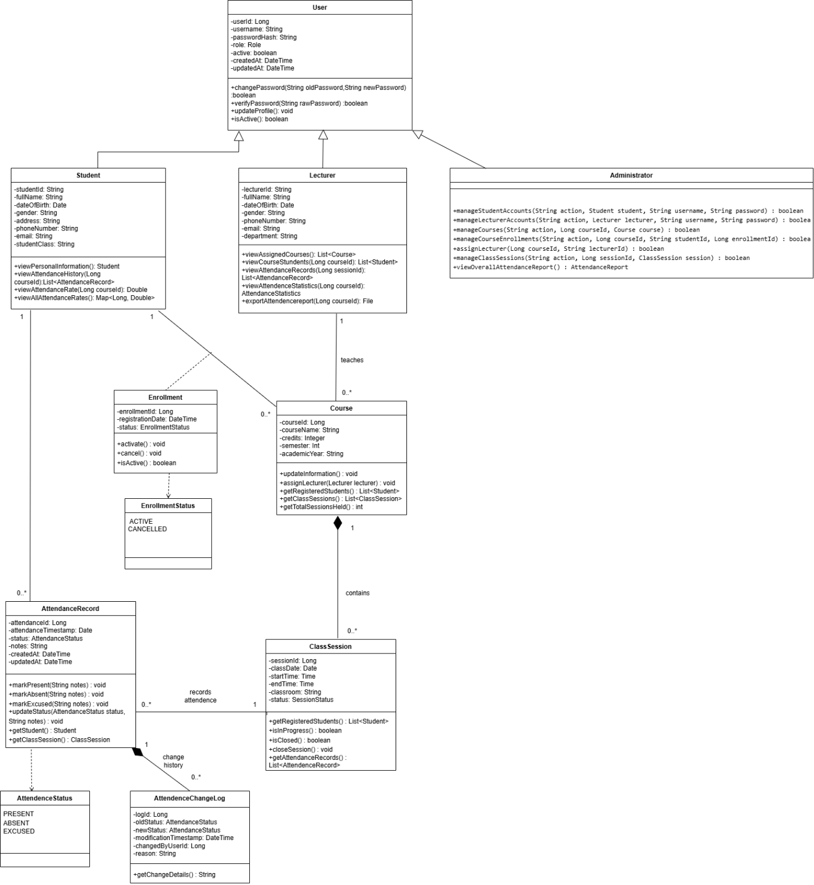

VIII.Data Model

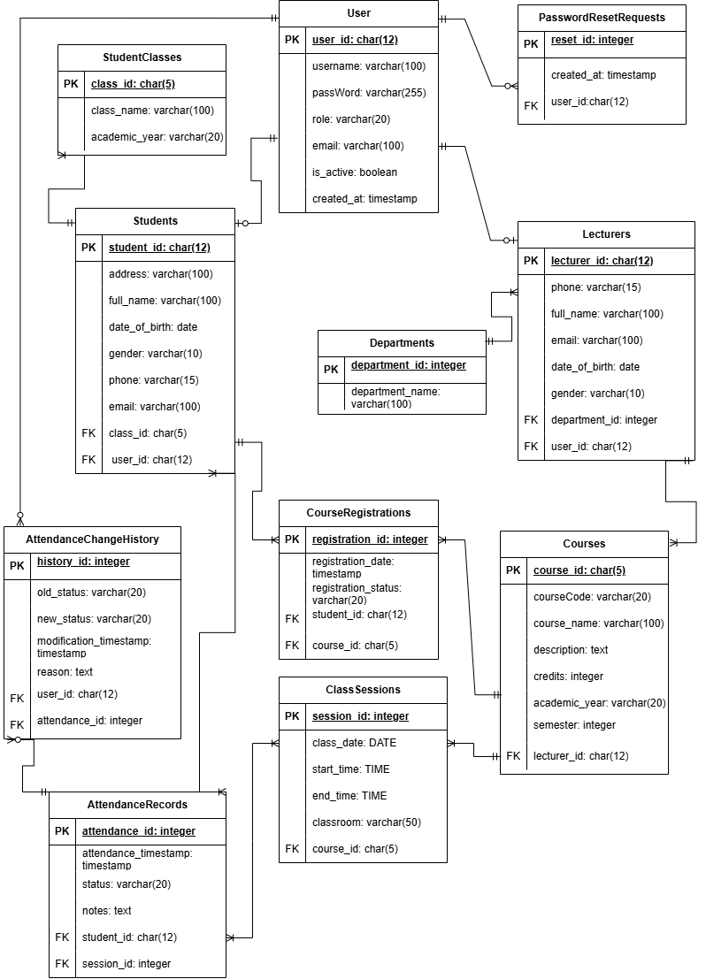
IX.Interface Design Description
1. System Overview
The Student Attendance Management System is developed to support the management of student information, lecturer information, courses, classes, and attendance activities.
The system has three main user roles:
Administrator: Manages and controls all major system operations.
Lecturer: Manages assigned courses and records student attendance.
Student: Views personal attendance history and attendance rates.
Each user role is provided with different functions according to its assigned permissions.
2. Login and Authentication
The login function allows users to access the system using their assigned username and password.
The functions include:
Login: Users enter their username and password to access the system.
Remember Me: Allows the system to remember the user's login information.
Forgot Password: Allows users to submit a support request when they forget their password.
Role-Based Access: After successfully logging in, the system automatically redirects users to the appropriate interface based on their roles: Administrator, Lecturer, or Student.
3. Administrator Functions
The Administrator has permission to manage and control the system's data and major operations.
3.1. Dashboard
Displays an overview of the system's operational status, including statistics related to students, lecturers, courses, and attendance activities.
3.2. Student Management
Allows the Administrator to manage student information in the system, including:
Adding new students.
Editing student information.
Deleting student records.
Viewing student lists and detailed information.
3.3. Lecturer Management
Allows the Administrator to manage lecturer information, including adding, editing, deleting, and viewing lecturer records.
3.4. Account Management
Allows the Administrator to manage user accounts, assign roles, and control access permissions within the system.
3.5. Department Management
Allows the Administrator to manage department information within the university, including adding, editing, deleting, and viewing department lists.
3.6. Class Management
Allows the Administrator to manage class lists and information related to each class.
3.7. Course Management
Allows the Administrator to manage course information, including creating, updating, deleting, and viewing course details.
3.8. Course Registration
Allows the Administrator to manage student course registrations and monitor the list of students enrolled in each course.
3.9. Lecturer Assignment
Allows the Administrator to assign lecturers to the appropriate courses.
3.10. Class Session Management
Allows the Administrator to manage class sessions associated with each course, including session schedules and time information.
3.11. Attendance Reports
Allows the Administrator to view and generate attendance reports and monitor students' class participation.
3.12. Attendance Change History
Allows the Administrator to track the history of attendance record modifications, including:
The person who made the change.
The attendance status before and after the modification.
The modification date and time.
The reason for the change.
3.13. Change Password and Logout
Change Password: Allows the Administrator to change the account password.
Logout: Ends the current session and logs the user out of the system.
4. Lecturer Functions
Lecturers use the system to manage their assigned courses, record student attendance, and monitor students' class participation.
4.1. Dashboard
Displays an overview of the lecturer's courses, class sessions, and attendance status.
4.2. My Courses
Allows lecturers to view the list of courses assigned to them by the Administrator.
4.3. Class Sessions
Allows lecturers to view information and schedules of class sessions belonging to their assigned courses.
4.4. Take Attendance
Allows lecturers to record student attendance for each class session by updating attendance statuses:
Present: The student attends the class session.
Late: The student arrives late.
Absent: The student does not attend the class session.
4.5. Attendance Records
Allows lecturers to view student attendance lists and detailed attendance information for their assigned courses.
4.6. Attendance Statistics
Provides attendance statistics to help lecturers monitor students' class participation rates.
4.7. Attendance Change History
Allows lecturers to review the history of attendance record modifications. When making changes, lecturers are required to provide a reason for the modification.
4.8. Export Reports
Allows lecturers to export attendance data for reporting and storage purposes:
CSV: Exports detailed attendance records.
PDF: Exports summarized attendance reports for courses.
4.9. My Profile
Allows lecturers to view and update certain personal information, such as phone numbers and email addresses. Identification information, department details, and teaching assignments are managed by the Administrator.
4.10. Change Password and Logout
Allows lecturers to change their account passwords and log out of the system.
5. Student Functions
Students use the system to monitor their personal information and attendance records.
5.1. Dashboard
Displays an overview of the student's learning progress and attendance status.
5.2. Attendance History
Allows students to review their personal attendance history by course and date.
5.3. Attendance Rate
Displays the student's class participation rate, including:
Attendance Rate: Calculated by dividing the total number of Present and Late sessions by the total number of recorded attendance entries.
On-Time Attendance Rate: Calculated by dividing the number of Present sessions by the total number of recorded attendance entries.
Class sessions without attendance records are excluded from the denominator and are not automatically counted as absences.
Students can filter attendance information by course or date to monitor their attendance results.
5.4. My Profile
Allows students to view their personal information stored in the system.
5.5. Change Password and Logout
Allows students to change their account passwords and log out of the system.
6. General System Functions
Login: Authenticates users using usernames and passwords.
Role-Based Access: Asssigns access permissions based on three roles: Administrator, Lecturer and student.
Profile Management: Allows users to view or update personal information according to their permissions.
Change Password: Allows users to change their account passwords.
Forgot Password: Allows users to submit a password recovery request.
Logout: Ends the user's current session.
Change History Tracking: Records modifications made to attendance data.
Export Reports: Supports exporting attendance data in CSV and PDF formats.

7. Conclusion
The Student Attendance Management System provides essential functions to support information management and attendance activities in an educational environment.
With three main user roles: Administrator, Lecturer, and Student, the system clearly separates user permissions, supports centralized data management, enables attendance recording, and provides attendance history and statistical reports.
As a result, the system helps improve management efficiency, reduce manual operations, and make the process of monitoring students' class participation more convenient.

